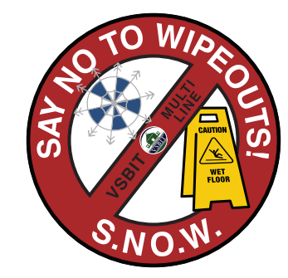**Say NO to Wipeouts! (S.NO.W.) Action Plan**

*December:*

*January:*

*February:*

*March:*

*April:*

*May:*

*June:*

*September:*

*October:*

*November:*